5G-CN Microservices Architecture Development

|  |  |
| --- | --- |
| Editor: | BUPT |
| Deliverable nature: | Public |
| Due date: |  |
| Delivery date: | 12, 2017 |
| Version: | 0.1 |
| Total number of pages: |  |
| Reviewed by: |  |
| Keywords: | EPC, OAI，5G-CN，Microservices，AMF,SMF,UPF,AUSF |

Abstract

The deliverable presents the 5G-CN microservices developed by BUPT, its design and implementation.

List of authors

|  |  |
| --- | --- |
| **School** | **Authors** |
| **BUPT** | Luhan Wang, Zeyu Pu,Xinli Zhou, Keliang Du |

Table of Contents

Table of Contents

1 Introduction

1.1 Overview

1.2 Development environment

2 5G-CN design anddevelopment

2.1 AMF and SMF

2.2 MME Splitting Design

2.3 ITTI DEMO Deployment

2.4 Replace esm_sap_send()

2.5 How to process itti return value**.**

2.6 splitting UE ESM context from UE EMM context

Abbreviations

5GC 5G Core Network

AMF Access and Mobility Management Function

SMF Session Management Function

AUSF Authentication Server Function

5G-GUTI 5G Globally Unique Temporary Identity

UDSF Unstructured Data Storage network function

UDM Unified Data Management

EMM EPC Mobility Management

ESM EPC Session Management

1 Introduction

**1. 1 Overview**

The 5G System architecture is defined to support data connectivity and services enabling deployments to use techniques such as e.g. Network Function Virtualization and Software Defined Networking. The 5G System architecture shall leverage service-based interactions between Control Plane (CP) Network Functions where identified. Some key principles and concept are to:

- Separate the User Plane (UP) functions from the Control Plane (CP) functions, allowing independent scalability, evolution and flexible deployments e.g. centralized location or distributed (remote) location.

- Modularize the function design, e.g. to enable flexible and efficient network slicing.

- Wherever applicable, define procedures (i.e. the set of interactions between network functions) as services, so that their re-use is possible.



**Non-Roaming 5G System Architecture in reference point representation**

**1.2 Development environment**

**OpenAirInterface (OAI)**

A separate legal entity from EURECOM, which aims to provide an open-sourceecosystem for the core (EPC) and access-network (EUTRAN) protocols of 3GPP cellular systems with the possibility of interoperating with closed-source equipment in either portion of the network.include openairinterface5g and openair-cn.



**OAI Network test platform**

2 5G-CN design and development

**2.1 AMF and SMF**

The Access and Mobility Management function (AMF) includes the following functionality. Some or all of the AMF functionalities may be supported in a single instance of a AMF:

- Termination of RAN CP interface (N2).

- Termination of NAS (N1), NAS ciphering and integrity protection.

- Registration management.

- Connection management.

- Reachability management.

- Mobility Management.

- Lawful intercept (for AMF events and interface to LI System).

- Provide transport for SM messages between UE and SMF.

- Transparent proxy for routing SM messages.

- Access Authentication.

- Access Authorization.

- Provide transport for SMS messages between UE and SMSF.

- Security Anchor Function (SEA). It interacts with the AUSF and the UE, receives the intermediate key that was established as a result of the UE authentication process. In case of USIM based authentication, the AMF retrieves the security material from the AUSF.

- Security Context Management (SCM). The SCM receives a key from the SEA that it uses to derive access-network specific keys.

Regardless of the number of Network functions, there is only one NAS interface instance per access network between the UE and the CN, terminated at one of the Network functions that implements at least NAS security and mobility management.

The Session Management function (SMF) includes the following functionality. Some or all of the SMF functionalities may be supported in a single instance of a SMF:

- Session Management e.g. Session establishment, modify and release, including tunnel maintain between UPF and AN node.

- UE IP address allocation & management (incl optional Authorization).

- Selection and control of UP function.

- Configures traffic steering at UPF to route traffic to proper destination.

- Termination of interfaces towards Policy control functions.

- Control part of policy enforcement and QoS.

- Lawful intercept (for SM events and interface to LI System).

- Termination of SM parts of NAS messages.

- Downlink Data Notification.

- Initiator of AN specific SM information, sent via AMF over N2 to AN.

- Determine SSC mode of a session.



**Create AMF and SMF modules by splitting MME**

**2.2 MME Splitting Design**

Implement the interface between ESM and EMM

* communication procedures need to be accomplished
* using ITTI to implement the communication between ESM and EMM

Implement ESM and EMM as different service module



Change synchronous calls into asynchronous messages



**2.3 ITTI DEMO deployment**

**Important points:**

First；define demo_messages_def.h in the appropriate directory

Eg:MESSAGE_DEF(MESSAGE_DEMO,MESSAGE_PRIORITY_MED, message_demo_t, message_demo)

Then；in the same directory demo_messages_types.h defines message type which is to transfer.

Eg: #define DEMO_DATA_IND(mSGpTR) (mSGpTR)->ittiMsg.message_demo

typedef struct message_demo_s {

const char *name;

const char *university;

} message_demo_t

Final；add demo_message_def.h to messages_def.h;at the same time in main.c achieve the function of transfer information through ITTI.

Specifically；

|  |  |  |
| --- | --- | --- |
| main | itti_create_task | Two explaining parameters: TASK and &function |
| main | itti_alloc_new_message()  itti_send_msg_to_task() | Packaging information and transfer:MESSAGE_DEMO (message_p) |
| &FUNCTION | While(1)  itti_receive_msg(&message)  func(&message)  itti_free(&message) | Func is processing information  FUNCTION is a pointer function |



ITTI Communication between different tasks

**2.4 Replace esm_sap_send()**

Splitting esm from emm, First of all，we change the synchronized function esm_sap_send to itti asynchronous type. Imitating ITTI DEMO deployment,in the next dectroys:

src/nas/emm/Detach.c

src/nas/emm/Attach.c

src/nas/emm/LowerLayer.c

src/nas/emm/sap/emm_cn.c

there is esm_sap_send().

Eg: rc = esm_sap_send (&esm_sap); in Attach.c

|  |  |  |
| --- | --- | --- |
| 1 | itti_create_task (TASK_ESM_MME, &esm_sap_send_test, NULL) | crete a new task in src/mme_app/mme_app_main.c |
| 2 | esm_sap_send(&esm_sap); | itti_send_msg_to_task(message_p)  define.esm_sap_test_t.in src/common/esm_sap_test_messages_types.h as transfering message instead of esm_sap_t |
| 3 | int esm_sap_send_test()  { while(1)  itti_receive_msg(message_p);  function(message_p)  } | Function esm_sap_send_test() achieve  the same function as esm_sap_send() |
| 4 | Add function corresponding to x.h eg: esm_sap_send_test into esm_sap.h | Others functions esm_sap_send the same as the above steps |

**2.5 How to process itti return value.**

When we completed the above work , we notice there's no return value from *itti_send_msg_to_task*. But in previous procedure calls, the following actions after *esm_sap_send* will depend on the return value. So one solution that comes to our minds is that, also change EMM procedure into ITTI, and send back return value to EMM task via itti_send_msg_to_task.

We find in Attach.c there are two places about return value.One is ESM_DEFAULT_EPS_BEARER_CONTEXT_ACTIVATE_CNF. The other is ESM_UNITDATA_IND.

ESM_DEFAULT_EPS_BEARER_CONTEXT_ACTIVATE_CNF：

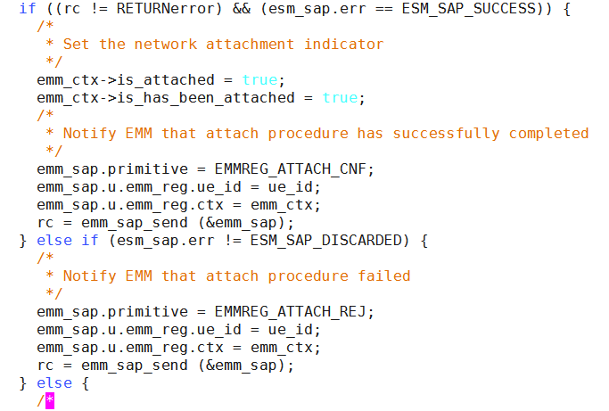

We still use itti to solve this type of problem.

|  |  |  |
| --- | --- | --- |
| 1 | Put above figure words into esm_sap.c with case: ESM_DEFAULT_EPS_BEARER_CONTEXT_ACTIVATE_CNF | use itti, changes {emm_sap} into  emm_reg_p message,definde in mme_app_messages_def.h |
| 2 | emm_sap_send(&emm_sap) | itti_send_msg_to_task(emm_reg_p )  the same way |
| 3 | create the task  while(1)  { itti_receive_msg(message_p)  switch (ITTI_MSG_ID (message_p))  case: ...function  } | new task is located in:  [src/nas/nas_mme_task.c](https://github.com/OPENAIRINTERFACE/openair5g-cn/commit/6a6d33d80a9b58cab3a6fa4178b1e16a0e2caac7#diff-94d064963f75506f1f98b0128ab59e5d)  Function achieve the same function as emm_sap_send() |

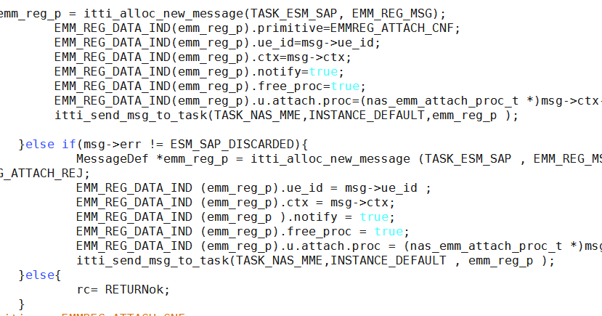

ESM_UNITDATA_IND:

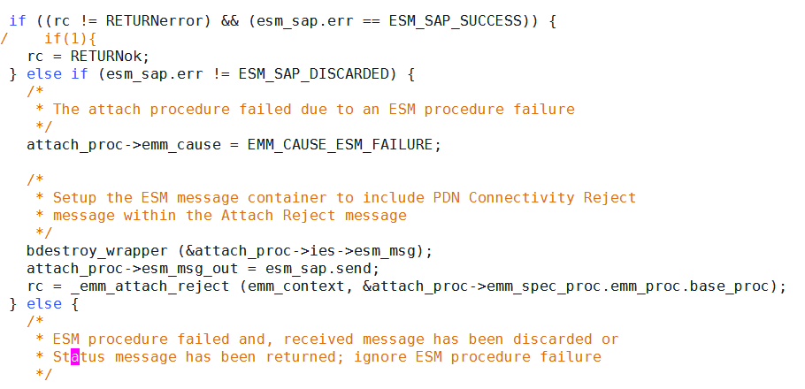

|  |  |  |
| --- | --- | --- |
| 1 | Put above figure words into esm_sap.c with case: ESM_UNITDATA_IND T_ACTIVATE_CNF | Notice：_emm_attach_reject(emm_context, &attach_proc->emm_spec_proc.emm_proc.base_proc) |
| 2 | itti_send_msg_to_task(message_p)  replace _emm_attach_reject() | Define a message structure itti_nas_emmas_establish_rej_t; by redefining the two parameters of the function _emm_attach_reject() |
| 3 | create the task  while(1)  { itti_receive_msg(message_p)  switch (ITTI_MSG_ID (message_p))  case: ...function | In the function create a new function nas_emm_attach_reject(message_p)  { 1.achieve Attach.c some function eg:  bdestroy_wrapper ();  attach_proc->esm_msg_out = msg->send;  2._emm_attach_reject()  } |
| 4 | Add function corresponding to x.h | In the emm_proc.h add to  #include "intertask_interface.h"  nas_emm_attach_reject(itti_nas_emmas_establish_rej_t * msg); |

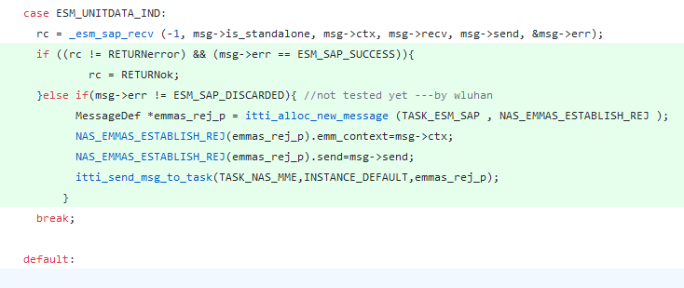

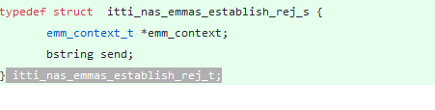

**2.6 splitting UE ESM context from UE EMM context**

* **Current**：
  + ESM and EMM context are coupled together.

*emm_context_s->esm_context*

* **After:**
  + Create a collection of PDN/ESM contexts, store them in a hashtable



We want to run esm and emm in different threads such as taskA, taskB，emm_context_s is Struct A and Struct B is esm_context, so We create a new hash mechanism to store esm_context based on the original hashtable.

Firstly: create four hashtables function in src/nas/emm/emm_main.c

struct esm_context_s* esm_get_inplace(struct guti_s guti,struct esm_context_s **esm_p);

int esm_insert(struct guti_s, struct esm_context_s);

int esm_init(void);

void esm_exit(void);

1.struct esm_context_s* esm_get_inplace(struct guti_s guti,struct esm_context_s **esm_p)

{

struct esm_context_s *esm_context_t=NULL;

obj_hashtable_get(esm_hash_pointer,&guti,Key_size,(void **)&esm_context_t);

*esm_p=esm_context_t;

if(ESM_DEBUG)

{

printf("esm_p: %p\n",esm_p);

}

return *esm_p;

}

2. int esm_insert(struct guti_s guti_t, struct esm_context_s esm_context_t)

{

if(ESM_DEBUG)

{

printf("\nesm_insert start\n");

}

char* cid=malloc(sizeof(struct guti_s)+1);

if(cid)

{

memcpy(cid,&guti_t,sizeof(struct guti_s));

}

struct esm_context_s * data=malloc(sizeof(struct esm_context_s));

if(data)

{

memcpy(data,&esm_context_t,sizeof(struct esm_context_s));

}

/*hashtable_rc_t rc=obj_hashtable_insert(esm_hash_pointer,(void*)&guti_t,Key_size,&esm_context_t);*/

hashtable_rc_t rc=obj_hashtable_insert(esm_hash_pointer,cid,Key_size,data);

if(ESM_DEBUG)

{

struct esm_context_s * p;

esm_get_inplace(guti_t,&p);

if(memcmp(p,&esm_context_t,sizeof(struct esm_context_s))==0)

{

printf("wo get p: %p \n",p);

printf("n_pnds %d \n",p->n_pdns);

}else

{

printf("\nNOT SAME\n");

}

printf("\nesm_insert end\nTEST\n");

}

if(HASH_TABLE_OK==rc) return RETURNok;

else return RETURNerror;

}

3. struct esm_context_s* esm_remove(struct guti_s guti)

{

if(ESM_DEBUG)

{

printf("\nesm_remove start\n");

}

struct esm_context_s *esm_context_t=NULL;

obj_hashtable_remove(esm_hash_pointer,&guti,Key_size,(void **)&esm_context_t);

return esm_context_t;

}

4. int esm_init(void)

{

if(ESM_DEBUG)

{

printf("\nesm_init start\n");

}

esm_hash_pointer=obj_hashtable_create(32,NULL,free_wrapper,free_wrapper,NULL);

if(esm_hash_pointer) return RETURNok;

else RETURNerror;

}

Next we find all of emm_context_s->esm_context, Through the above method, splitting esm_context from emm_conetext eg:

/src/nas/esm/esm_information.c: nas_stop_T3489(&ue_context->esm_ctx)

{ struct esm_context_s * esm_p;

esm_get_inplace(ue_context->_guti,&esm_p);

/*

* Stop T3489 timer if running

*/

/*nas_stop_T3489(&ue_context->esm_ctx);*/

if (apn) {

/*if (ue_context->esm_ctx.esm_proc_data->apn) {*/

if (esm_p->esm_proc_data->apn) {

/*bdestroy_wrapper(&ue_context->esm_ctx.esm_proc_data->apn);*/

bdestroy_wrapper(&esm_p->esm_proc_data->apn);

}

/*ue_context->esm_ctx.esm_proc_data->apn = bstrcpy(apn);*/

esm_p->esm_proc_data->apn = bstrcpy(apn);

}

}

A total of 67 related places, we use the similar method of separation.